**For Immediate Release**

Contact: Corinne Eaton

Director of Business Development

631-761-9626

ceaton@nailongsland.com

NAI LONG ISLAND REPRESENTS JUL-VET HOLDINGS LLC IN THE SALE OF A 7,130 SQUARE FOOT OFFICE BUILDING LOCATED AT 3400 VETERANS MEMORIAL HIGHWAY, BOHEMIA NY.

Islandia, New York – 6/02/2024 – NAI Long Island, an office of NAI Global, a leading global commercial real estate brokerage firm disclosed today that Senior Director Brian McGuire effectively facilitated the sale of 3400 Veterans Memorial Highway, Bohemia, NY. This accomplishment was achieved on behalf of both the owner, Jul-Vet Holdings, and the buyer, John King.

The all-cash deal closed for $2,000,000 or $281 PSF.

The buyer, John King, is an active commercial real estate investor that focuses on the Veterans Memorial Highway corridor and surrounding areas in Central Suffolk County

3400 Veterans Memorial Highway is a fully updated prime professional office building built in 2007. Its refined layout features 14 exclusive private offices, a spacious open bullpen area, a welcoming reception zone, a well-appointed kitchen, and a comfortable staff lounge.

Top of Form

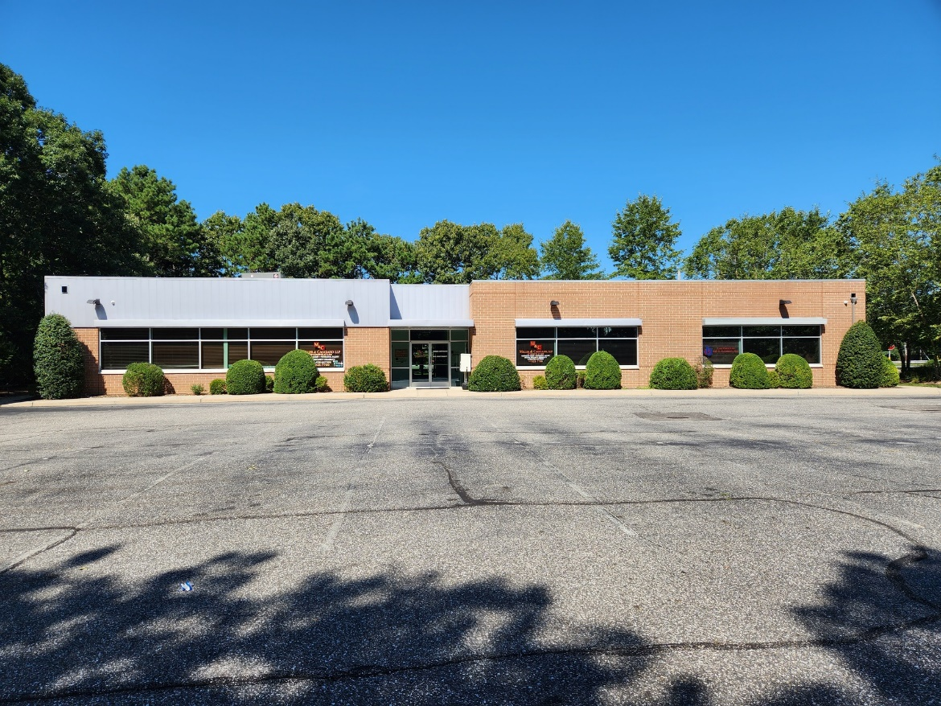

About NAI Long Island

NAI Long Island (NAI-LI) is an affiliate of NAI Global. NAI-LI is a commercial real estate brokerage firm with tenant and ownership representation, consulting advisory services, land use/zoning expertise, valuation, REO-OREO-foreclosure services, litigation support/expert witness and property management functions backed by NAI Global, a worldwide leader in the commercial real estate services industry.

NAI-LI enjoys a special understanding of Long Island’s office and industrial real estate market. It has sold or leased hundreds of offices and industrial properties in the region. Active in both landlord representation and tenant representation, NAI-LI serves as a window on the availability of properties in the region’s commercial real estate market.

The firm is a Licensed Real Estate Broker in the State of New York. NAI-LI negotiates leases on behalf of property owners as well as tenants and is regularly called upon to provide consulting advisory services on

the marketing potential of diverse property types. Over the years, NAI-LI has sold many office buildings,

industrial - warehouse flex buildings, retail properties and land, emerging as one of the best-known

commercial brokers on Long Island.

About NAI Global

NAI Global is a leading global commercial real estate brokerage firm. NAI Global offices are leaders in

their local markets and work in unison to provide clients with exceptional solutions to their commercial real estate needs. NAI Global has more than 375 offices strategically located throughout North America, Latin America, Europe, Africa and Asia Pacific, with over 6,000 local market professionals, managing in excess of over 1.15 billion square feet of property. Annually, NAI Global completes in excess of $20 billion in commercial real estate transactions throughout the world.

NAI Global provides a complete range of corporate and institutional real estate services, including,

brokerage and leasing, property and facilities management, real estate investment and capital market

services, due diligence, global supply chain and logistics consulting and related advisory services.

To learn more, visit www.nailongisland.com