For Immediate Release

Contact: Corinne Eaton
Director of Business Development
631-761-9626
ceaton@nailongsland.com

NAI LONG ISLAND NEGOTIATES THE SUCESSFUL SALE OF 15 MIDDLE AVENUE, HOLTSVILLE NEW YORK.

Islandia, New York – 5/22/2024 – NAI Long Island, an office of NAI Global, a leading global commercial real estate brokerage firm announced today that Senior Director Brian McGuire facilitated the sale of a 30,000 SF industrial building located at 15 Middle Avenue, Holtsville, NY. McGuire represent the Seller, Four R Realty, LLC. The Buer was not represented by a Broker.

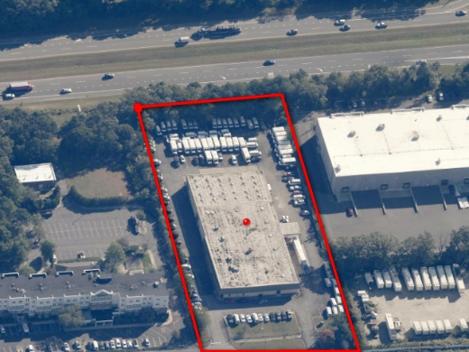
The all-cash transaction closed at $3,700,000 or $123.00 PSF. 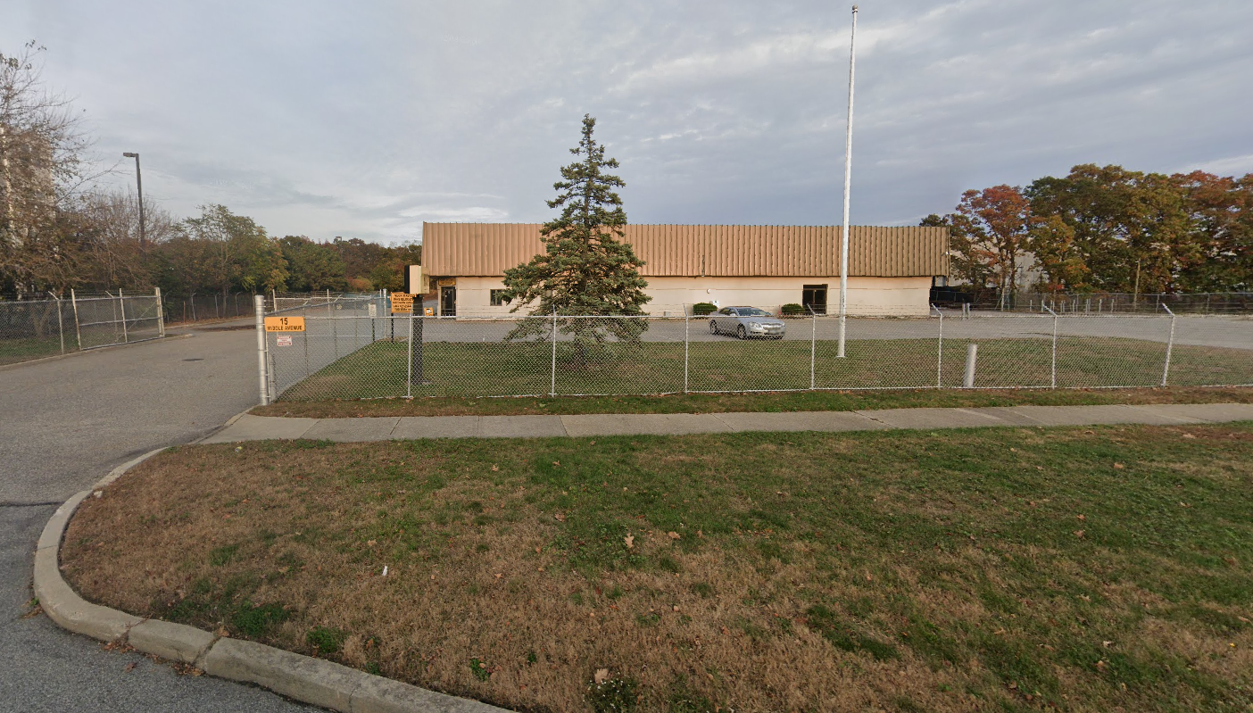

The 15 Middle Ave property will be owner occupied by TLC Transportation, a provider of non-emergency transportation services to facilities such as hospitals, nursing homes, doctor’s offices, dialysis centers, behavioral institutes and rehabilitation centers. TLC’s fleet of ambulatory vehicles consists of Medi-cars, mini-vans and passenger vans.

The building is a 30,000 SF, single tenant, industrial property located on 2.83 acres in the center of Suffolk County at the intersection of the Long Island Expressway and Nichols Road.

About NAI Long Island

NAI Long Island (NAI-LI) is an affiliate of NAI Global. NAI-LI is a commercial real estate brokerage firm with tenant and ownership representation, consulting advisory services, land use/zoning expertise, valuation, REO-OREO-foreclosure services, litigation support/expert witness and property management functions backed by NAI Global, a worldwide leader in the commercial real estate services industry.

NAI-LI enjoys a special understanding of Long Island’s office and industrial real estate market. It has sold or leased hundreds of offices and industrial properties in the region. Active in both landlord representation and tenant representation, NAI-LI serves as a window on the availability of properties in the region’s commercial real estate market.

The firm is a Licensed Real Estate Broker in the State of New York. NAI-LI negotiates leases on behalf of property owners as well as tenants and is regularly called upon to provide consulting advisory services on the marketing potential of diverse property types. Over the years, NAI-LI has sold many office buildings, industrial - warehouse flex buildings, retail properties and land, emerging as one of the best-known commercial brokers on Long Island.

About NAI Global

NAI Global is a leading global commercial real estate brokerage firm. NAI Global offices are leaders in
their local markets and work in unison to provide clients with exceptional solutions to their commercial real estate needs. NAI Global has more than 375 offices strategically located throughout North America, Latin America, Europe, Africa and Asia Pacific, with over 6,000 local market professionals, managing in excess of over 1.15 billion square feet of property. Annually, NAI Global completes in excess of $20 billion in commercial real estate transactions throughout the world.

NAI Global provides a complete range of corporate and institutional real estate services, including,
brokerage and leasing, property and facilities management, real estate investment and capital market
services, due diligence, global supply chain and logistics consulting and related advisory services.

To learn more, visit www.nailongisland.com

